**Operating System**

**(CT-353)**

Lab no 01

**Commands:**

**date:**



**cal:**

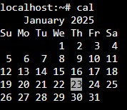

**echo:**



**ls:**



**whoami:**



**uptime:**



**uname:**



**hostname:**



**bc:**

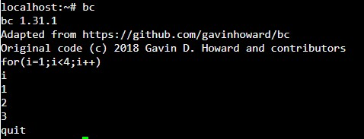

**clear:**

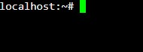

**cat;**



**rm:**

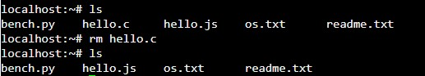

**wc:**

